UNIT II — NLP CONDENSED NOTES
1. SYNTAX AND SYNTACTIC ANALYSIS
Syntax
Syntax refers to the rules that govern how words are arranged to form meaningful and grammatically correct sentences.
It helps us understand:
- How words are arranged.
- How words form phrases.
- How phrases combine to form sentences.
Example:
The boy plays cricket.
The words follow a proper grammatical structure.
Syntactic Analysis
Syntactic Analysis is the process of analyzing the grammatical structure of a sentence.
In NLP, syntactic analysis helps determine the relationship between words and identifies how they combine to form phrases and sentences.
In simple words:
It checks the grammatical structure of a sentence.
Syntactic analysis is the main theme of Unit II and is connected with POS tagging, sequence labelling, grammars, and parsing.

2. PARTS OF SPEECH (POS)
Every word in a sentence belongs to a grammatical category called a Part of Speech.
Common POS categories include:
- Noun – name of a person, place, or thing
- Verb – action or state
- Adjective – describes a noun
- Adverb – describes a verb, adjective, or another adverb
- Pronoun – replaces a noun
- Preposition – shows relationship between words
- Conjunction – joins words or sentences
- Article/Determiner – words such as a, an, the
Example:
The intelligent student studies regularly.
Word | POS
The | Determiner
Intelligent | Adjective
Student | Noun
Studies | Verb
Regularly | Adverb

3. OPEN CLASS AND CLOSED CLASS WORDS
Words are broadly divided into two categories:
A) Open Class Words
Open class words are also called content words.
New words can easily be added to these categories.
Main types:
- Nouns – computer, city, student
- Verbs – run, study, eat
- Adjectives – beautiful, large, intelligent
- Adverbs – quickly, slowly, yesterday
Important point:
New words can enter open classes.
For example:
- New technology names can become nouns.
- Existing words can be used as new verbs.

B) Closed Class Words
Closed class words are also called function words.
The number of words in these categories is relatively fixed.
Examples include:
- Pronouns – he, she, they
- Determiners – a, an, the
- Prepositions – in, on, under
- Conjunctions – and, but, or
Easy Difference:
Open Class | Closed Class
New words can be added | Mostly fixed set of words
Content words | Function words
Noun, Verb, Adjective | Pronoun, Determiner, Preposition

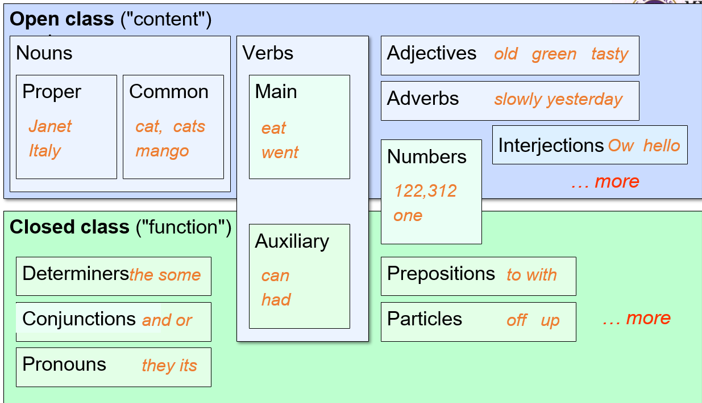

4. PART-OF-SPEECH TAGGING
Definition
Part-of-Speech Tagging, or POS Tagging, is the process of assigning a grammatical tag to each word in a sentence.
Example:
Sentence:
The boy plays football.
Tagged form:
- The → Determiner
- Boy → Noun
- Plays → Verb
- Football → Noun
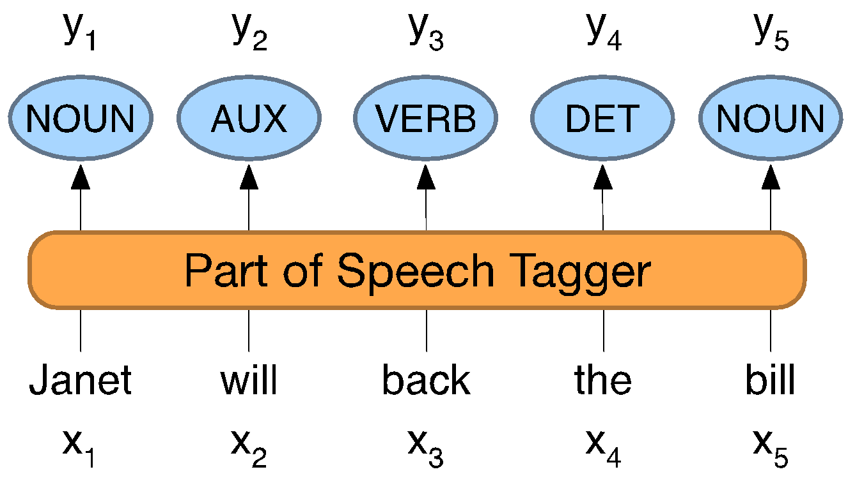
Why is POS Tagging Needed?
POS tagging can be useful for many NLP tasks.
1. Parsing
POS tagging can improve syntactic parsing.
Knowing whether a word is a noun, verb, etc., helps the system understand sentence structure.
2. Machine Translation
POS information can help in the correct reordering of words, such as adjectives and nouns, between languages.
3. Sentiment Analysis
The system may need to identify adjectives and other important POS categories that carry sentiment.
4. Text-to-Speech
Some words can have different pronunciations depending on their grammatical role.
Examples:
- lead
- object
POS tagging can help choose the correct pronunciation.
5. Linguistic Analysis
POS information can be useful while studying:
- Creation of new words
- Changes in word meaning
- Similarity and difference between words

5. POS AMBIGUITY
One word can sometimes belong to more than one grammatical category.
Example: Book
Book a ticket.
Here:
Book = Verb
But:
This is my book.
Here:
Book = Noun
Therefore, the POS tag cannot always be decided by looking only at the word.
The context of the word is also important.

6. MAIN APPROACHES TO POS TAGGING
The important POS tagging approaches in this unit are:
- Rule-Based POS Tagging
- Stochastic POS Tagging
Other sequence-based approaches include:
- Hidden Markov Model (HMM)
- Conditional Random Field (CRF)

7. RULE-BASED POS TAGGING
Rule-based POS tagging is one of the oldest POS tagging techniques.
It mainly uses:
- Dictionary or Lexicon
- Hand-written Rules
Working
Step 1: Find possible tags
The system uses a dictionary or lexicon to find possible POS tags for each word.
For example:
Book
may have possible tags:
- Noun
- Verb
Step 2: Apply rules
If a word has more than one possible tag, hand-written rules are used to identify the correct tag.
The rules use information such as:
- Previous word
- Next word
- Word ending
- Context
Main Idea:
Dictionary gives possible tags → Rules select the correct tag.

8. STOCHASTIC POS TAGGING
Stochastic POS Tagging uses:
- Frequency
- Probability
- Statistical information
A model is trained using a large annotated corpus.
The model learns patterns and characteristics of different parts of speech.
It then predicts the POS tag of a word based on:
- The context of the word
- The probability of different tags occurring in that context
Simple idea:
Instead of manually writing rules, the system uses statistical information from training data.
Rule-Based vs Stochastic Tagging
Rule-Based Tagging | Stochastic Tagging
Uses hand-written rules | Uses probability and statistics
Uses dictionary/lexicon | Uses training data
More manual work | Learns patterns from data
Rules decide the tag | Probability helps decide the tag

9. STOP WORDS
Stop words are commonly occurring words that may carry less useful information for certain NLP tasks.
Examples often include words such as:
- the
- is
- a
- an
- and
Depending on the NLP application, these words may be removed during text processing.
Important Note:
Stop words are task-dependent. They may be removed in some applications but can still be important for grammatical and syntactic analysis.
The Unit II syllabus specifically includes stop words along with POS tagging.

11. SEQUENCE LABELLING
Definition
Sequence Labelling is the task of assigning a label to every element in an input sequence.
In NLP, the input is usually a sequence of words, and the output is a sequence of labels.
Example: POS Tagging
Sentence:
The boy plays cricket
The output may be:
Word | Label/POS Tag
The | Determiner
Boy | Noun
Plays | Verb
Cricket | Noun
Therefore:
Input Sequence → Words
Output Sequence → Labels or Tags
POS tagging is a common example of sequence labelling. Other sequence models are also used in NLP for tasks such as named entity recognition.

12. HIDDEN MARKOV MODEL (HMM)
Definition
A Hidden Markov Model (HMM) is a statistical model used for sequence-based tasks, such as Part-of-Speech (POS) Tagging.
It uses probabilities and context to predict the most suitable sequence of POS tags.

Basic Idea
In HMM, there are two things:
1. Observations
These are the actual words that we can see.
Example:
The boy runs
2. Hidden States
These are the POS tags that need to be predicted.
Example:
DET → NOUN → VERB
It is called Hidden because words are visible, but their correct POS tags are predicted.

Main Components
1. Transition Probability
It shows the probability of moving from one POS tag to another.
$$P\left(y_{i}∣y_{i-1}\right)$$
Example:
$$P\left(Verb∣Noun\right)$$
It means the probability that a Verb follows a Noun.

2. Emission Probability
It shows the probability of observing a word given a POS tag.
$$P\left(x_{i}∣y_{i}\right)$$
Example:
$$P\left(plays∣Verb\right)$$
It means the probability of the word plays occurring as a Verb.

HMM for POS Tagging
For the sentence:
The dog runs
Possible tags are:
DET → NOUN → VERB
HMM uses:
- Transition Probability → Tag to Tag
- Emission Probability → Tag to Word
Using these probabilities, it selects the most likely sequence of POS tags.

Stochastic Tagging
HMM is a statistical or stochastic approach.
It uses:
- Frequency
- Probability
- Training data
Two simple approaches are:
- Word Frequency: Assign the tag that occurs most frequently with a word.
- Tag Sequence Probability: Select tags based on the probability of the tag sequence.

Quick Summary
Term | Meaning
HMM | Hidden Markov Model
Observation | Actual word
Hidden State | POS Tag
Transition | Tag → Tag
Emission | Tag → Word

22. CONDITIONAL RANDOM FIELD (CRF)
Definition
Conditional Random Fields (CRFs) are a class of probabilistic graphical models commonly used in Machine Learning and Natural Language Processing.
In NLP, CRFs are mainly used for sequence labelling tasks.
That means they assign labels to each element in a sequence.
Applications of CRF
CRFs can be used for:
1. POS Tagging
Assigning grammatical tags to words.
Example:
The → DET
boy → NOUN
runs → VERB
2. Named Entity Recognition (NER)
Identifying entities such as:
- People
- Organizations
- Locations
How CRF Works
A CRF:
- Takes the observed input data.
- Predicts the labels of the sequence.
- Considers the relationship or dependency between neighbouring labels.
Simple flow:
Input Words
↓
Observed Data
↓
CRF Model
↓
Predicted Sequence of Labels
The important feature of CRF is that it considers dependencies between nearby labels while predicting the sequence.

23. NAMED ENTITIES
Definition
A Named Entity is something that can be referred to using a proper name.
Named entities are often multi-word phrases.
The common entity categories mentioned in the PPT are:
Tag | Meaning | Example
PER | Person | Marie Curie
LOC | Location | New York City
ORG | Organization | Stanford University
GPE | Geo-Political Entity | Boulder, Colorado
The term is also extended to items such as:
- Dates
- Times
- Prices
24. NAMED ENTITY RECOGNITION (NER)
Definition
Named Entity Recognition (NER) is the task of identifying named entities in text and assigning the correct entity type to them.
The two main tasks of NER are:
1. Find the Span
Find the part of the text that represents a proper name.
2. Assign the Entity Type
Tag the identified entity with its correct category.
Example
Sentence:
Marie Curie visited New York City.
NER identifies:
- Marie Curie → PER
- New York City → LOC
So, NER performs both:
Identification + Classification

25. NER USING CRF
CRF can be used for NER because NER is also a sequence labelling problem.
Training Phase
The CRF model is trained using a labelled dataset containing:
- Input text
- Correct entity labels
The model learns patterns from the labelled data.
Prediction Phase
After training, the model receives new text and predicts the entity labels.
Simple Flow:
Labelled Training Data
↓
CRF Model
↓
Learns Patterns
↓
New Text
↓
Predict Entity Labels

26. APPLICATIONS OF NER
According to the PPT, NER is useful in the following applications:
1. Sentiment Analysis
NER can help identify whether sentiment is related to a particular:
- Company
- Person
2. Question Answering
NER helps identify important entities in questions and text, making it useful in question-answering systems.
3. Information Extraction
NER is an important component of Information Extraction because it helps identify useful entities from unstructured text.
27. HMM vs CRF
HMM | CRF
Statistical model | Probabilistic graphical model
Used for sequence tasks | Used for sequence labelling
Uses hidden states and observations | Uses observed data to predict labels
Uses transition and emission probabilities | Considers dependencies between neighbouring labels
Can be used for POS tagging | Can be used for POS tagging and NER

🧠 EASY REVISION
CRF
A probabilistic graphical model used for sequence labelling.
Main CRF Feature
Uses observed data and considers dependencies between neighbouring labels.
Named Entity
Something referred to using a proper name.
Common NER Tags
- PER → Person
- LOC → Location
- ORG → Organization
- GPE → Geo-Political Entity
NER
Finds spans of text representing proper names and assigns their entity types.

28. CONSTITUENCY
Meaning of Constituency
The fundamental idea of constituency is that a group of words can behave as a single unit or phrase, called a constituent.
Example: Noun Phrase (NP)
A noun phrase can be a single word:
- She
- Michael
Or a group of words:
- The house
- Russian Hill
Although some noun phrases contain multiple words, they behave as one grammatical unit.

29. CONTEXT-FREE GRAMMAR (CFG)
Definition
A Context-Free Grammar (CFG) is a mathematical system commonly used for modelling the constituent structure of English and other natural languages.
CFG is also called:
- Phrase-Structure Grammar
- A formalism equivalent to Backus-Naur Form (BNF)
A CFG consists of:
- A set of grammar rules or productions
- Symbols representing grammatical structures
- A lexicon of words and symbols
The rules describe how symbols can be grouped and ordered together.

30. FORMAL REPRESENTATION OF CFG
A context-free grammar is represented as:
$$G=\left\langle T , N , S , R\right\rangle$$
Where:
T = Set of Terminals
These are the words or basic symbols of the language.
N = Set of Non-Terminals
These represent grammatical categories or phrase structures.
S = Start Symbol
The starting symbol of the grammar. It is one of the non-terminals.
R = Rules or Productions
Rules that describe how symbols can be rewritten.
The general form is:
$$X→γ$$
where:
- $X$is a non-terminal.
- $γ$is a sequence of terminals and/or non-terminals.
A grammar $G$generates a language $L$.

31. TERMINALS AND NON-TERMINALS
The symbols used in CFG are divided into two main classes.
A. Terminal Symbols
Terminal symbols are the final and basic symbols of a language.
They cannot be changed or replaced further.
In NLP, terminals usually correspond to actual words.
Examples:
- the
- nightclub
- book
- flight
The lexicon contains rules that introduce terminal symbols.
B. Non-Terminal Symbols
Non-terminals are temporary symbols or variables that can be expanded using production rules.
They represent:
- Phrase structures
- Groups of words
- Grammatical categories
Examples:
- S
- NP
- VP
- A
- B
Example Rule:
$$S→aSb$$
Here:
- S is a non-terminal.
- a and b are terminals.
Terminal vs Non-Terminal
Terminal | Non-Terminal
Final symbol | Can be expanded
Cannot be replaced further | Replaced using production rules
Represents actual words | Represents phrase structures
Example: the, book | Example: S, NP, VP

32. PRODUCTION RULES
A CFG consists of a set of production rules.
A general production rule is:
$$X→γ$$
Left-Hand Side (LHS)
The left side contains:
A single non-terminal symbol.
Right-Hand Side (RHS)
The right side contains:
An ordered list of one or more terminals and/or non-terminals.
The rules tell us how grammatical structures can be expanded.
33. COMMON CFG SYMBOLS
Some common grammatical symbols are:
Symbol | Meaning
S | Sentence
NP | Noun Phrase
VP | Verb Phrase
PP | Prepositional Phrase
Det | Determiner
Noun | Noun
Verb | Verb
Prep | Preposition

34. EXAMPLE OF CFG RULES
A simple grammar can contain rules such as:
$$S→NP VP$$
This means:
A sentence consists of a Noun Phrase followed by a Verb Phrase.

Noun Phrase Rules
$$NP→Pronoun \\ NP→Proper\text{-}Noun \\ NP→Det Nominal$$

Nominal Rules
$$Nominal→Noun \\ Nominal→Nominal Noun \\ Nominal→Nominal PP$$

Verb Phrase Rules
$$VP→Verb \\ VP→Verb NP \\ VP→VP PP$$
Prepositional Phrase Rule
$$PP→Prep NP$$
These rules show how a sentence can be divided into smaller grammatical units.

35. LEXICAL RULES
Lexical rules connect grammatical categories with actual words.
For example:
Determiner
$$Det→the∣a∣this$$
Noun
$$Noun→book∣flight∣meal$$
Verb
$$Verb→book∣include∣prefer$$
Thus, CFG rules finally expand into actual words.

36. SIMPLE CFG DERIVATION
Consider the grammar:
$$S→NP VP$$
Suppose:
$$NP→Det Nominal$$
and:
$$Nominal→Noun$$
The sentence structure is gradually expanded from:
$$S$$
to:
$$NP VP$$
and then into smaller grammatical components until actual terminal words are produced.
Simple Flow:
S
↓
NP + VP
↓
Smaller grammatical units
↓
Actual words
This process of replacing non-terminals using grammar rules is called a derivation.

37. PRETERMINALS
In NLP, the set of non-terminals may include a special set called:
Preterminals
A preterminal is a symbol that directly rewrites as a terminal.
For example:
$$Noun→book$$
Here, Noun acts as a grammatical category immediately before the terminal word.
The formal CFG description in the PPT distinguishes these preterminal symbols as part of the set of non-terminals.

🧠 CFG — EASY WAY TO REMEMBER
CFG contains four main things:
$$\boxed{G=\left\langle T , N , S , R\right\rangle }$$
Remember:
T → Terminals
Actual words
N → Non-Terminals
Grammar categories
S → Start Symbol
Starting point
R → Rules
Production rules
🔥 IMPORTANT EXAM DIFFERENCE
Terminal
Final symbol that cannot be replaced further.
Non-Terminal
A variable that can be expanded using production rules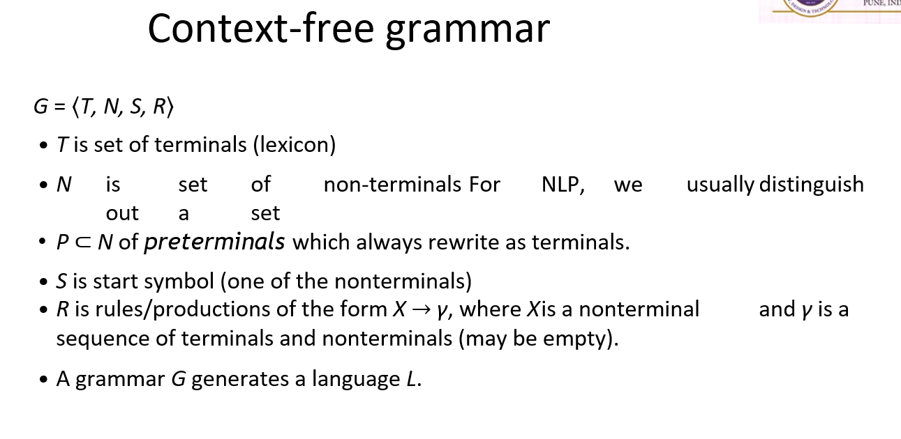
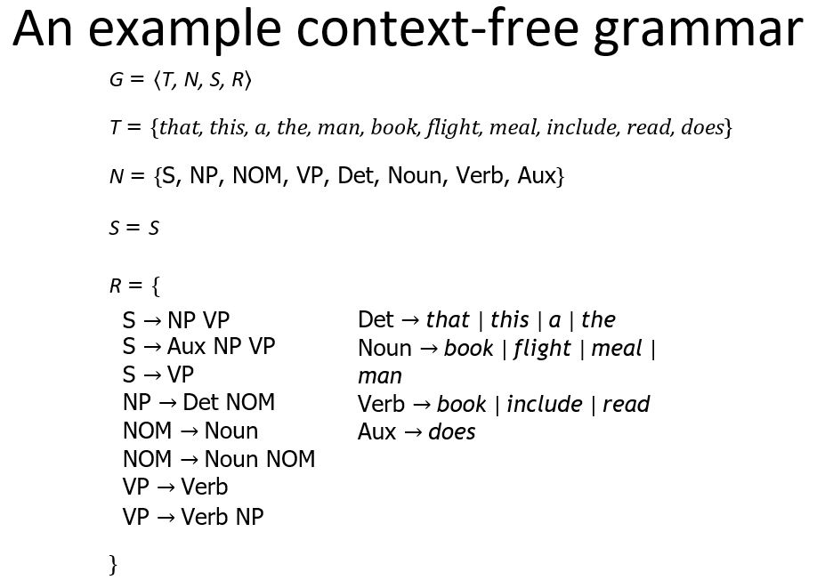
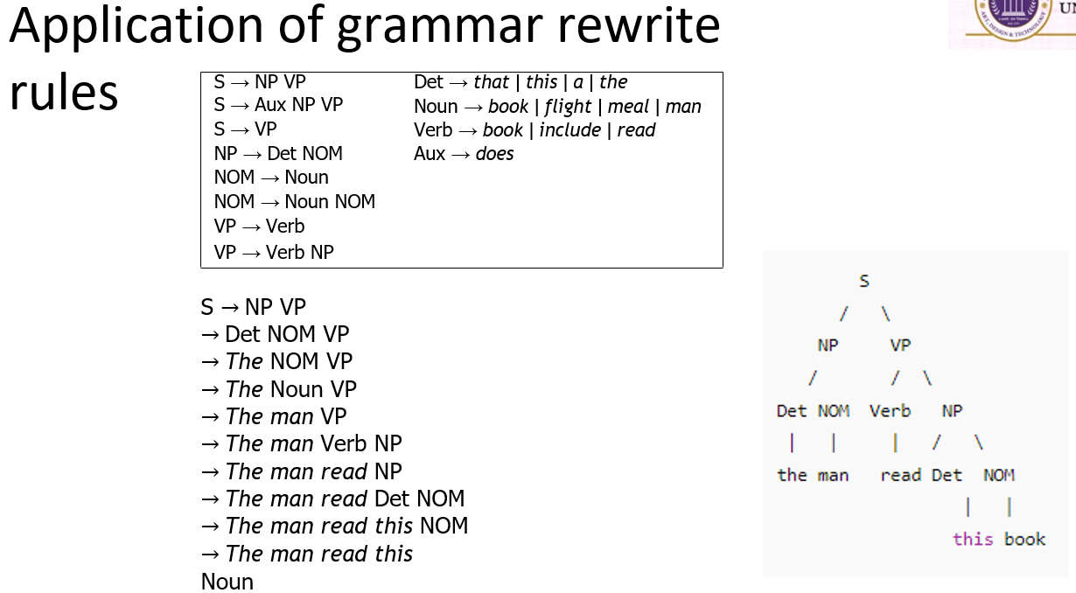
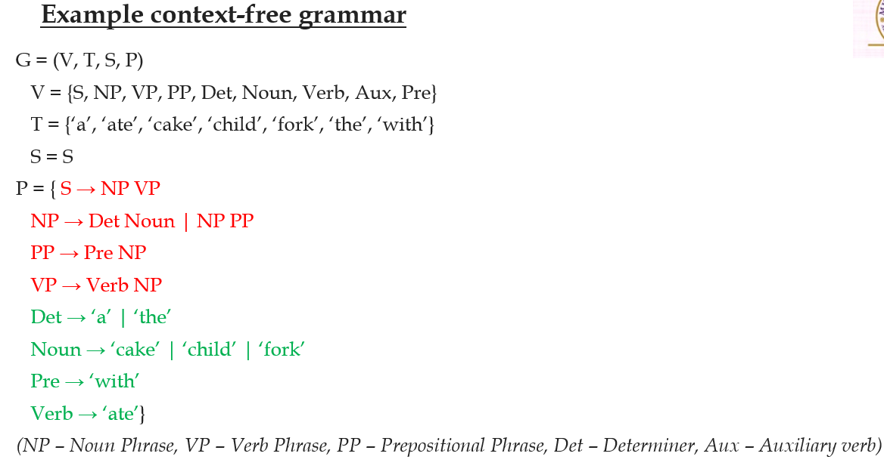
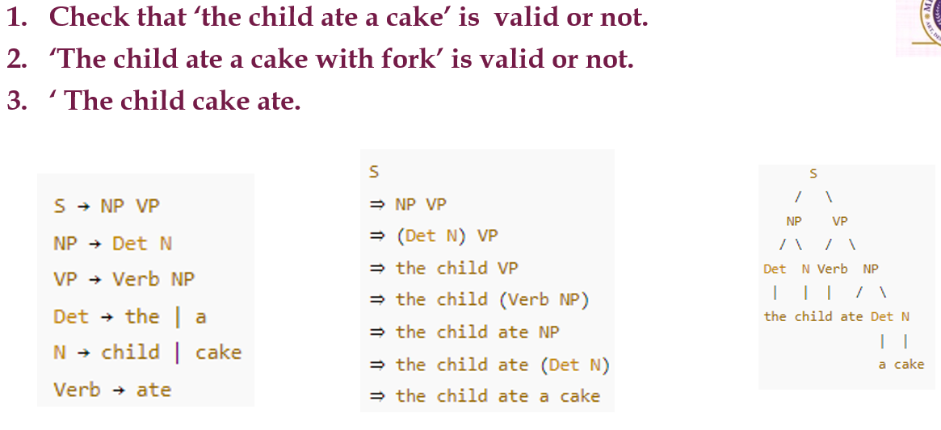
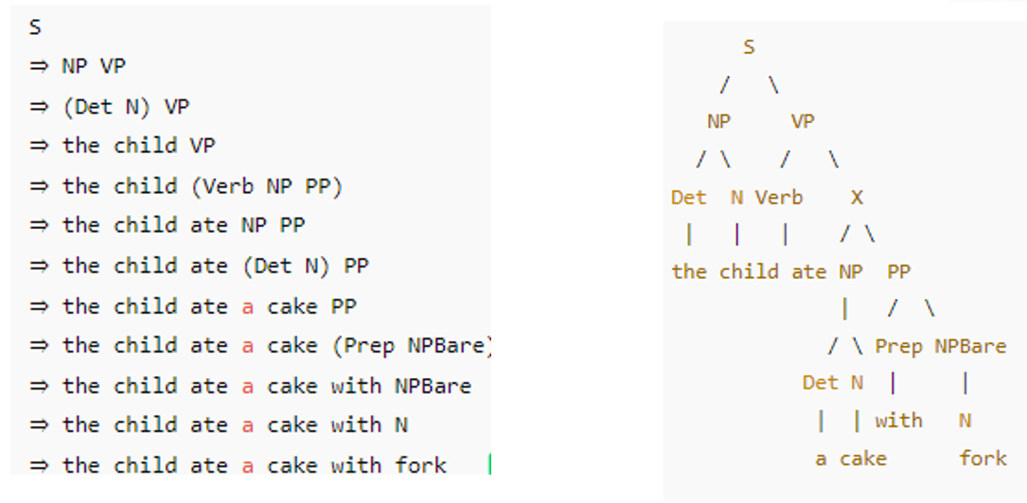
38. PARSING
Definition
Parsing is the process of automatically assigning a complete context-free or phrase-structure tree to an input sentence.
In simple words:
Parsing finds the grammatical structure of a sentence.
A parse tree shows how words combine to form phrases and finally a complete sentence.
Importance of Parsing
Parse trees are useful in applications such as:
- Grammar checking
- Word-processing systems
- Language analysis
- Other NLP applications
A sentence that cannot be parsed may contain grammatical errors.

39. PARSE TREE
A parse tree is a tree representation of the grammatical structure of a sentence.
Consider the rule:
$$S→NP VP$$
This means:
A Sentence consists of a Noun Phrase and a Verb Phrase.
A simple structure is:
S
/ \
NP VP
The tree is further expanded until we reach the actual words of the sentence.
Main idea:
Sentence
↓
Phrases
↓
Words

40. PARSING AS A SEARCH PROBLEM
A sentence may have different possible grammatical structures.
Therefore, parsing can be considered a search problem.
The parser searches through grammar rules to find a structure that matches the input sentence.
There may be choices between different rules, so search techniques can be used.
Two important approaches are:
- Top-Down Parsing
- Bottom-Up Parsing

41. TOP-DOWN PARSING
Definition
Top-down parsing starts from the highest-level grammar symbol, usually the Start Symbol (S).
It gradually expands the grammar until it reaches the words in the input sentence.
Simple Flow:
$$S→Phrases→Words$$
Therefore, top-down parsing moves:
From general structure to actual words.
Working of Top-Down Parsing
Step 1
Start with the Start Symbol:
$$S$$
Step 2
Apply a grammar rule.
For example:
$$S→NP VP$$
Step 3
Expand the non-terminals:
$$NP→Det Nominal \\ VP→Verb NP$$
Step 4
Continue expanding until the generated structure matches the input sentence.
Example
Suppose the input sentence is:
Book that flight
The grammar may contain rules such as:
$$S→VP \\ VP→Verb NP \\ NP→Det NOM \\ NOM→Noun$$
Then lexical rules are used to reach the actual words. The PPT illustrates top-down parsing using grammar expansion and breadth-first search.
Search Methods
Top-down parsing can use:
- Depth-First Search
- Breadth-First Search
The parser searches through possible grammar expansions until it finds a suitable structure.
Problems with Top-Down Parsing
1. Left Recursion
Consider:
$$NP→NP PP$$
This rule can lead to infinite recursion.
2. Many Possible Rules
If many rules have the same Left-Hand Side (LHS), the parser may waste time trying unsuitable rules.
3. Useless Work
A top-down parser may expand grammatical structures that are possible according to the grammar but do not actually appear in the input sentence.
The PPT describes this as doing work without bottom-up evidence.
Main Advantage
Top-down parsing performs well when useful grammar-driven control is available because the search is directed by grammar rules.
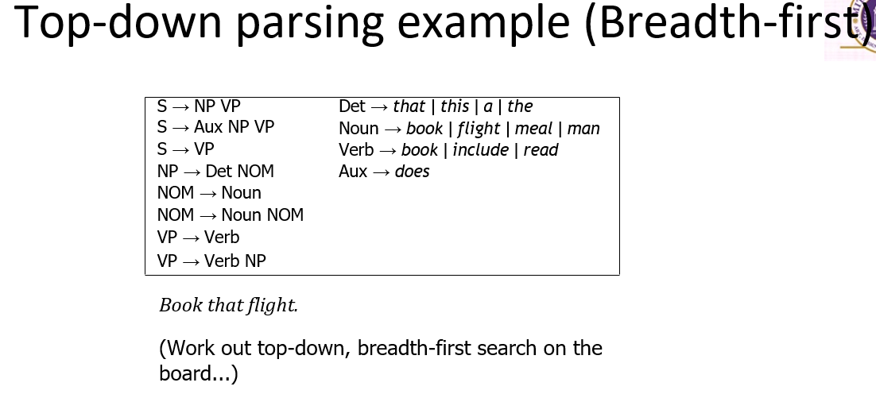
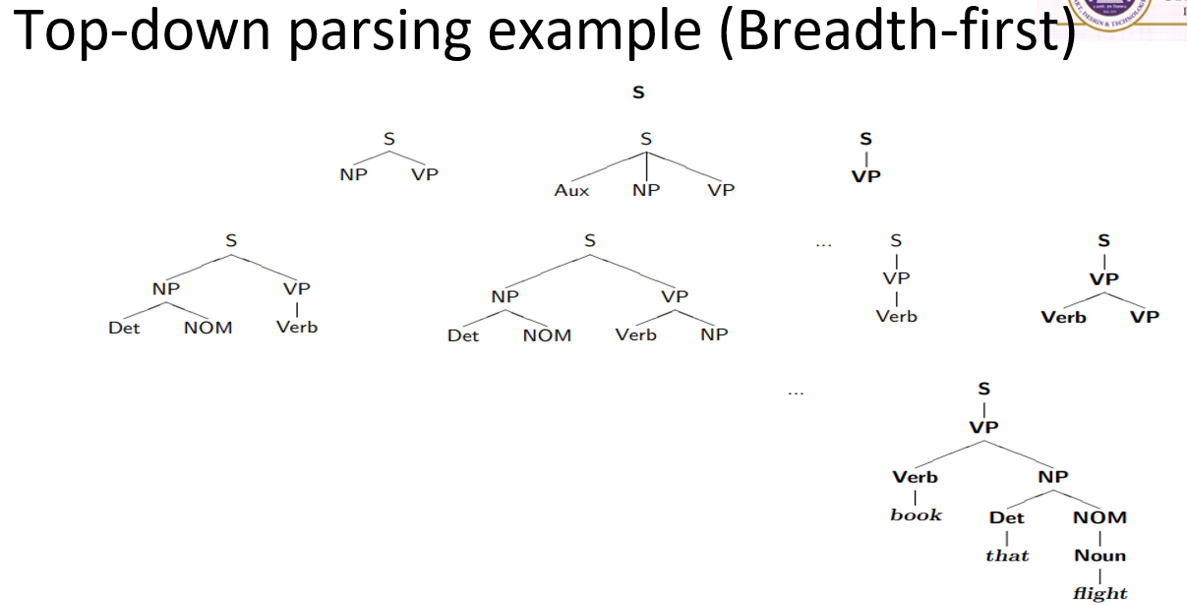

42. BOTTOM-UP PARSING
Definition
Bottom-up parsing starts with the actual words in the input sentence.
It gradually combines them into larger grammatical structures until it reaches the Start Symbol.
Simple Flow:
$$Words→Phrases→S$$
Therefore:
Bottom-up parsing moves from the input data towards the complete sentence structure.
Working
The initial goal list contains the input sentence.
If a sequence matches the Right-Hand Side (RHS) of a grammar rule, that sequence can be replaced by the Left-Hand Side (LHS).
Example:
Suppose:
$$NP→Det Noun$$
If the parser finds:
$$Det Noun$$
it can replace it with:
$$NP$$
The process continues until only the Start Symbol remains.
$$S$$
When the goal list contains only the Start Symbol, parsing is complete.
Search Problem in Bottom-Up Parsing
Sometimes the RHS of more than one grammar rule may match the input.
Therefore, the parser must choose which rule to apply.
Possible search methods include:
- Depth-First Search
- Breadth-First Search
- Goal ordering
The standard presentation of bottom-up parsing is shift-reduce parsing.
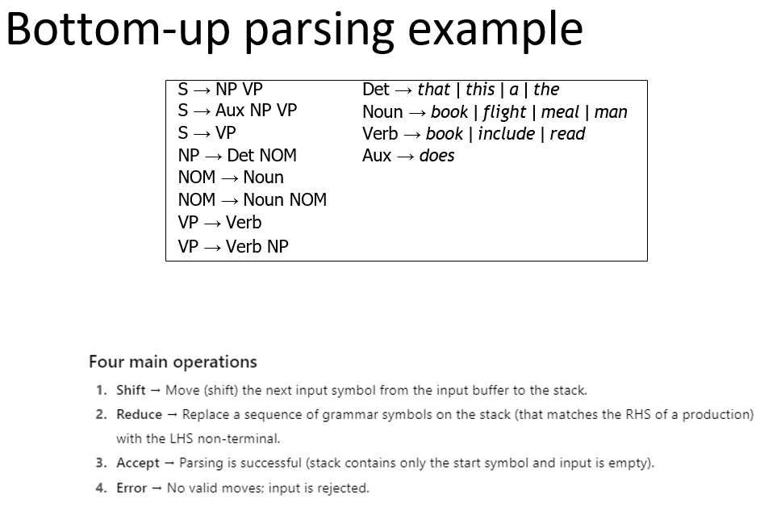

43. TOP-DOWN VS BOTTOM-UP PARSING
Top-Down Parsing | Bottom-Up Parsing
Starts with Start Symbol | Starts with input words
Moves from structure to words | Moves from words to structure
$$S→Words$$ | $$Words→S$$
Grammar-driven | Data/input-driven
May generate useless structures | Builds structures from actual input
Can face left recursion | Uses RHS matching

44. SHIFT-REDUCE PARSING
Shift-Reduce Parsing is the standard presentation of bottom-up parsing.
It uses mainly:
- Input Buffer – contains the sentence to be parsed.
- Stack – stores symbols during parsing.
Operations
1. Shift
The next input symbol is moved from the input buffer to the stack.
2. Reduce
When the top of the stack matches the RHS of a grammar rule, those symbols are removed and replaced with the corresponding LHS.
Example:
If:
$$NP→Det Noun$$
and the stack contains:
$$Det Noun$$
it can be reduced to:
$$NP$$
Success
Parsing is successful when only the START symbol remains on the stack.
If no shift or reduce operation is possible and the parser has not succeeded, it may backtrack.
Easy flow:
Input Buffer → SHIFT → Stack
↓
REDUCE
↓
START Symbol
↓
Success
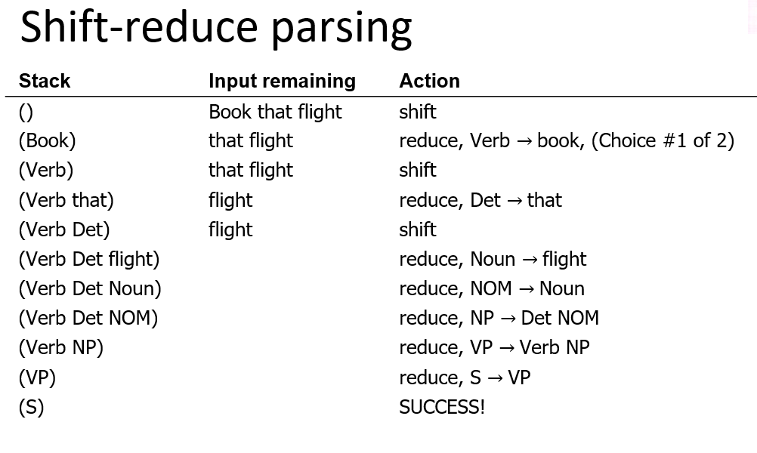

44. SHIFT-REDUCE PARSING
Shift-Reduce Parsing is a type of bottom-up parsing. It uses an input buffer and a stack.
Operations:
- Shift: Move the next input word to the stack.
- Reduce: Replace symbols matching the RHS of a grammar rule with its LHS.
Success:
Parsing is successful when the Start Symbol is obtained.

45. DYNAMIC PROGRAMMING PARSING
Dynamic Programming avoids repeated calculations by storing intermediate parsing results.
It makes parsing more efficient.
Main Methods:
- CKY: Bottom-up approach; requires grammar in CNF.
- Earley Parser: Top-down approach; does not require grammar normalization.
Chart parsers store intermediate results in a chart.

46. EARLEY PARSING
Earley Parsing is a dynamic programming method based on the top-down approach.
It does not require grammar conversion into CNF.
Main Operations:
- Prediction – Predict possible grammar rules.
- Scanning – Match the next input word.
- Completion – Complete a successfully matched rule.
Flow:
Predict → Scan → Complete

47. CHOMSKY NORMAL FORM (CNF)
For the CKY algorithm, the grammar is converted into CNF.
The production rules are generally of the form:
$$A→BC$$
where B and C are non-terminals, or:
$$A→a$$
where a is a terminal.

48. CKY PARSING
CKY (Cocke–Kasami–Younger) Parsing is a dynamic programming algorithm based on bottom-up parsing.
It requires the grammar to be in CNF.
Working:
- Start with the input words.
- Combine smaller phrases into larger phrases.
- Store results in a triangular chart.
- Continue until the complete sentence structure is obtained.
Flow:
Words → Small Phrases → Large Phrases → Sentence

Earley vs CKY
Earley | CKY
Top-down | Bottom-up
No CNF required | Requires CNF
Predict → Scan → Complete | Combines phrases using a chart

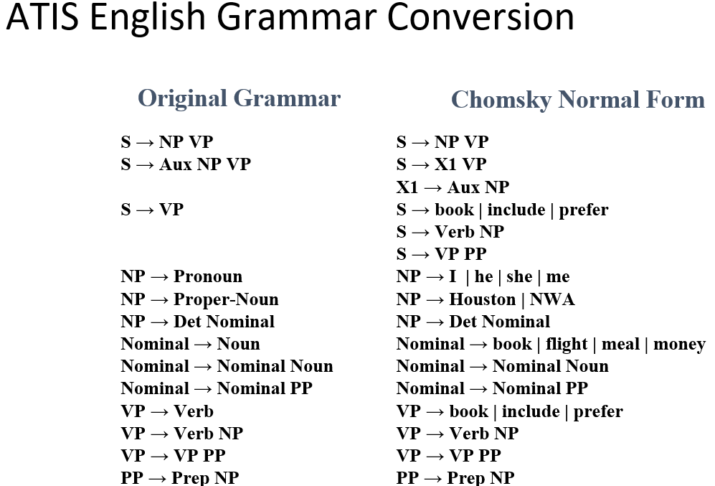
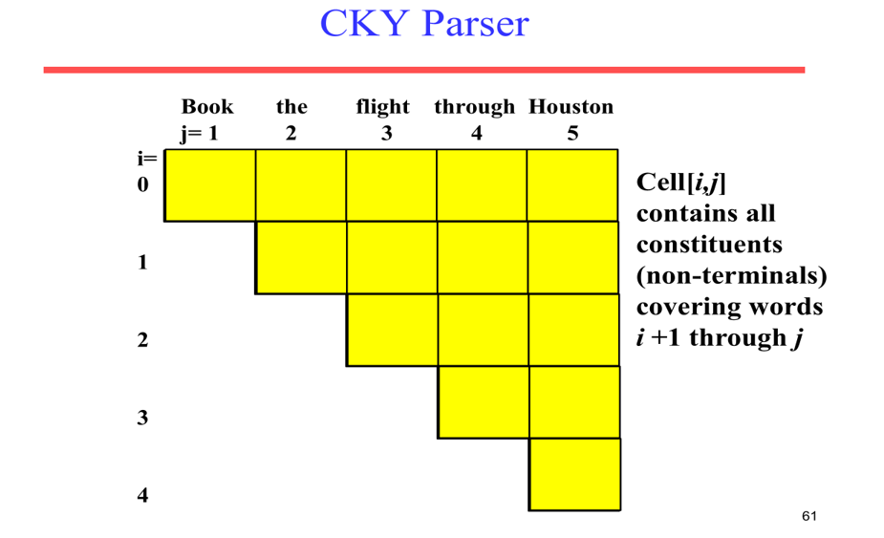
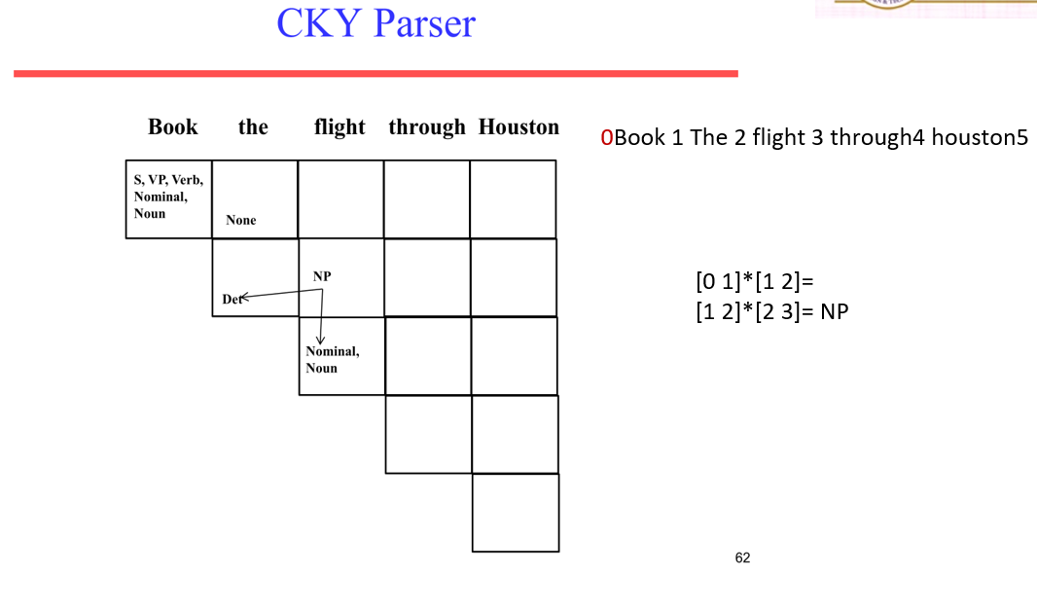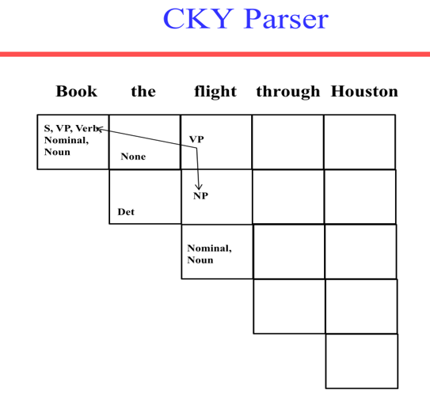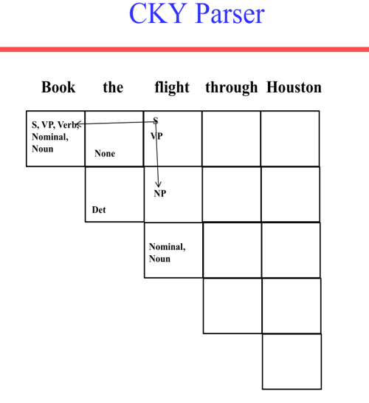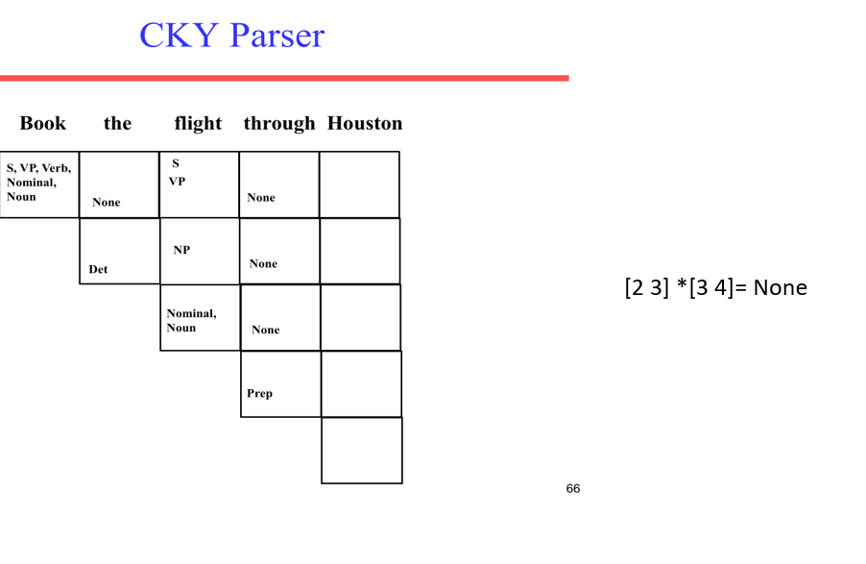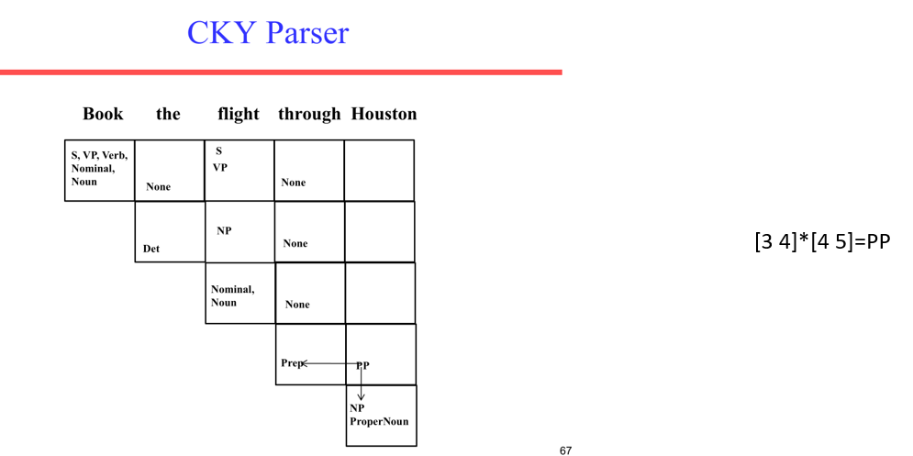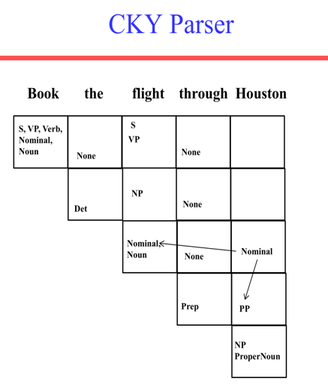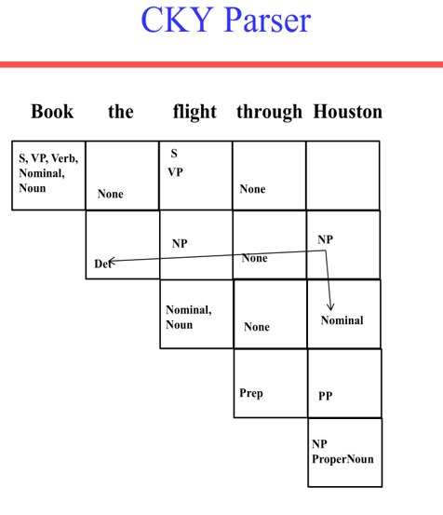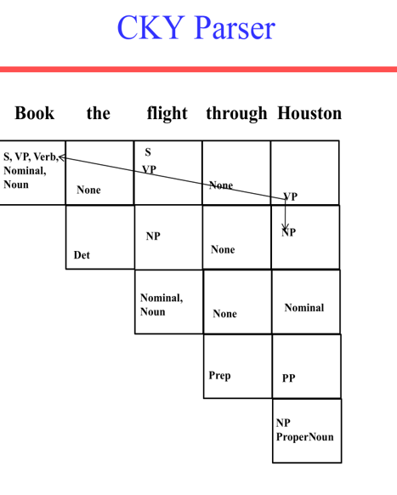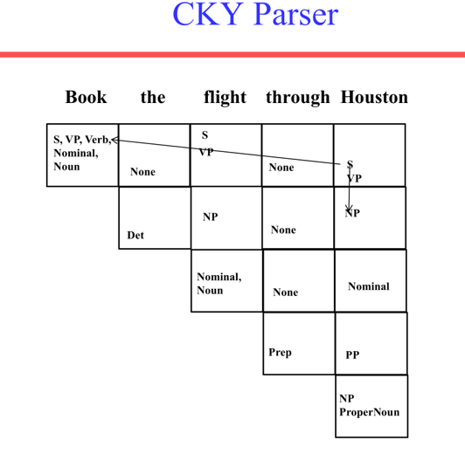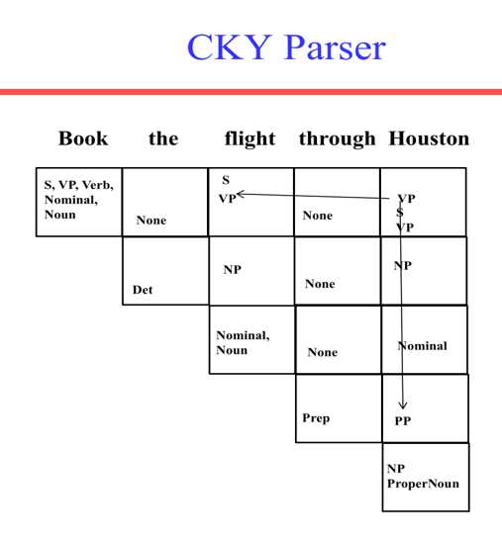
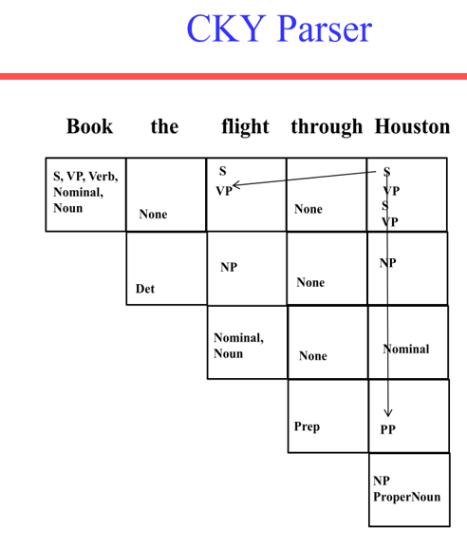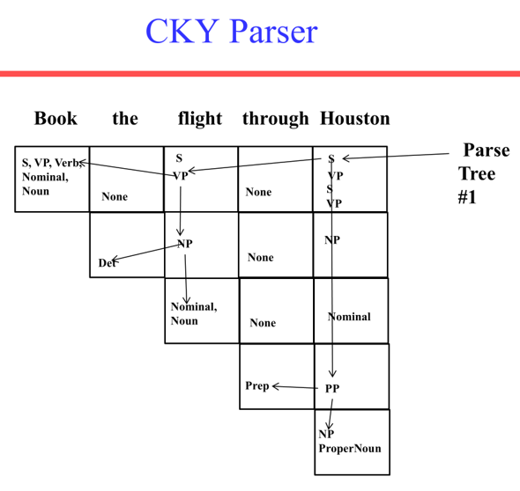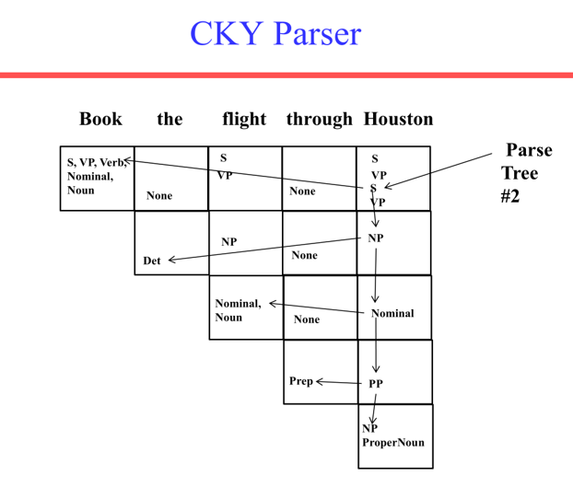
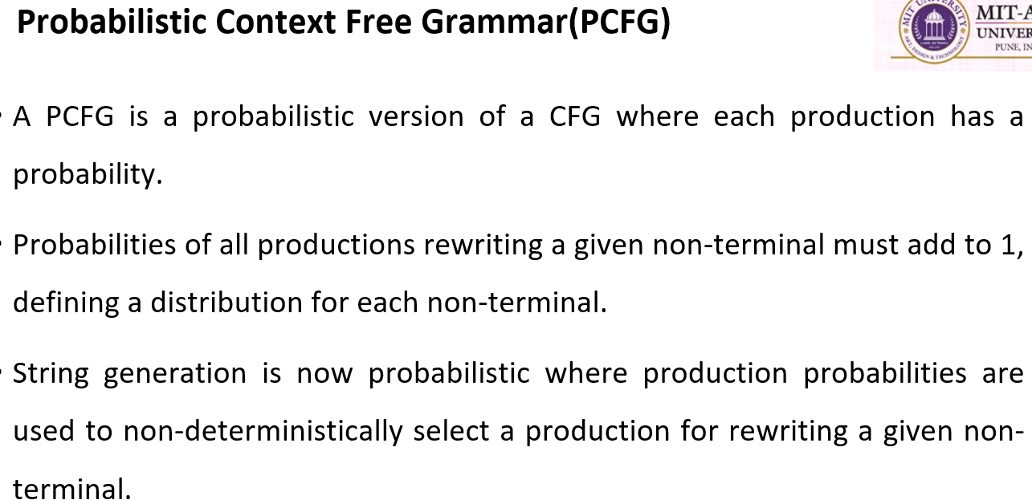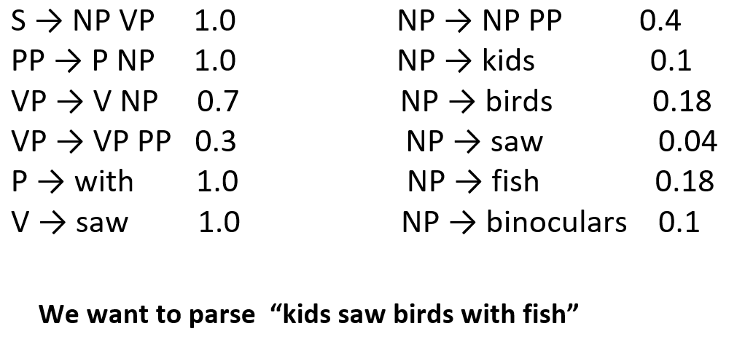
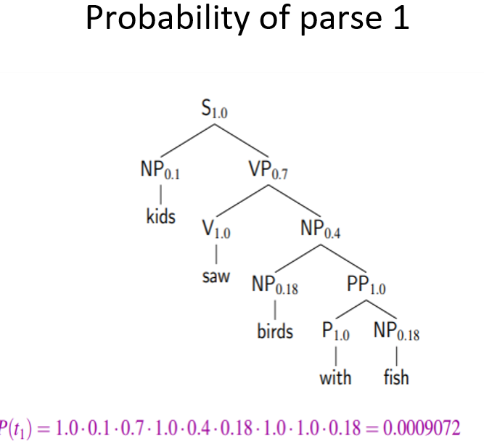
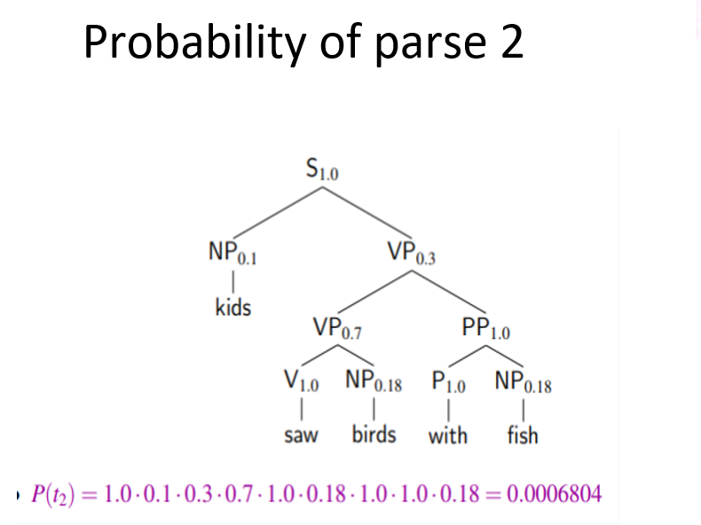
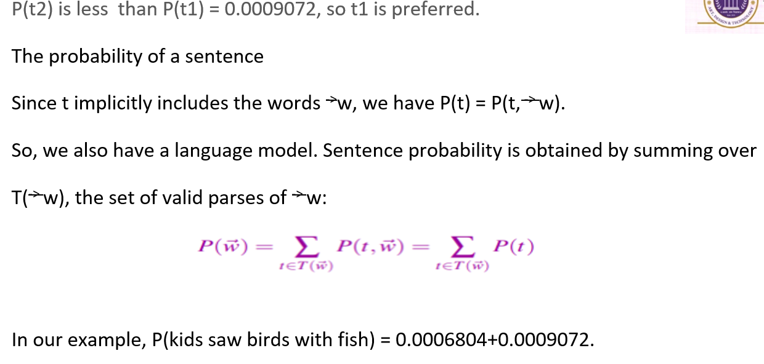
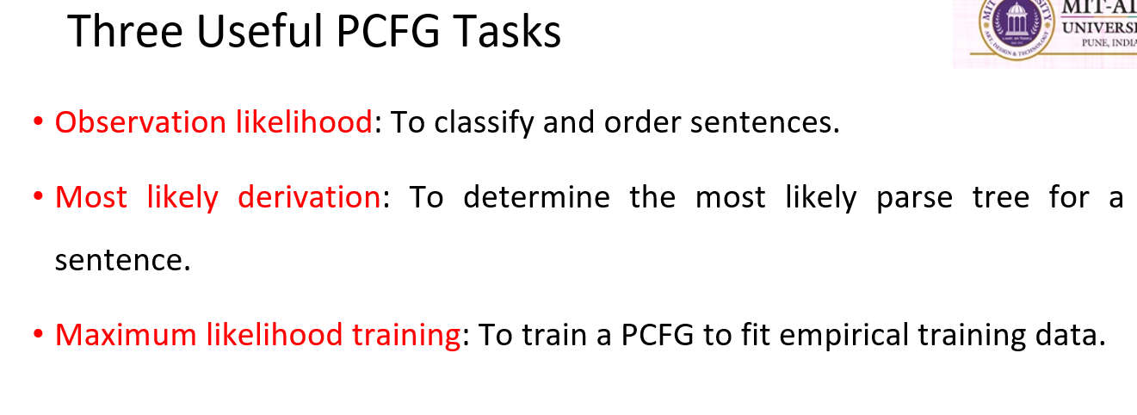
54. TERM FREQUENCY (TF)
Term Frequency (TF) measures how frequently a term or word appears in a document.
$$TF\left(t , d\right)=\frac{\text{Number of times term }t\text{ appears in document }d}{\text{Total number of terms in document }d}$$
Thus, every term can have a different TF value in each document.
Simple Meaning:
More occurrences of a word in a document generally mean a higher TF value.
55. INVERSE DOCUMENT FREQUENCY (IDF)
Inverse Document Frequency (IDF) measures how important a word is across a collection of documents.
Only TF is not enough because some words may occur frequently in almost every document.
$$IDF\left(t\right)=\log\left(\frac{\text{Total Number of Documents}}{\text{Number of Documents containing the term}}\right)$$
A word that occurs in many documents has a lower IDF value, while a rarer word has a higher IDF value.
Example:
If a word occurs in all 3 documents:
$$IDF=log⁡\left(3/3\right)=log⁡\left(1\right)=0$$

56. TF-IDF
TF-IDF combines Term Frequency and Inverse Document Frequency.
$$TF\text{-}IDF=TF×IDF$$
Words with a higher TF-IDF score are considered more important.
TF-IDF is high when:
- The word occurs frequently in one document.
- The word is rare across the complete collection of documents.
Easy Understanding:
Value | Meaning
High TF | Word occurs frequently in the document
High IDF | Word is rare across documents
High TF-IDF | Word is important for that document
Bag of Words vs TF-IDF
Bag of Words mainly represents the number of word occurrences.
TF-IDF assigns weighted importance to words and generally provides more useful information for machine learning models.
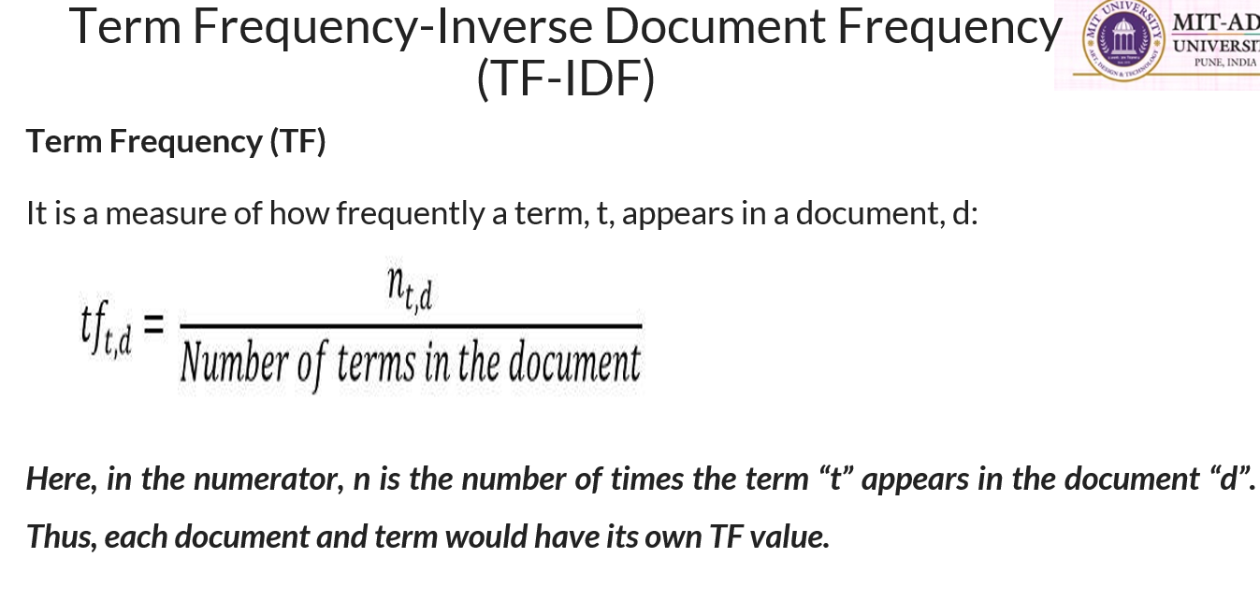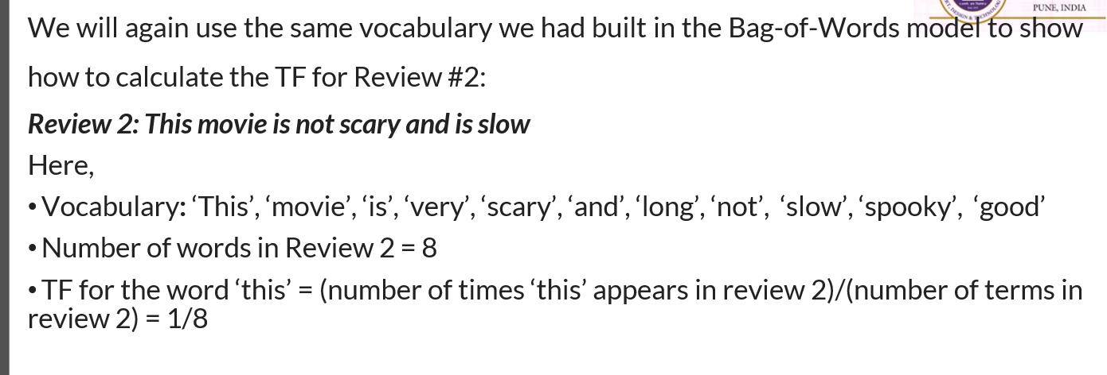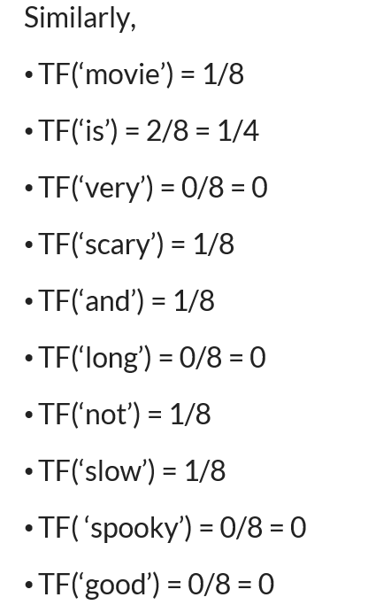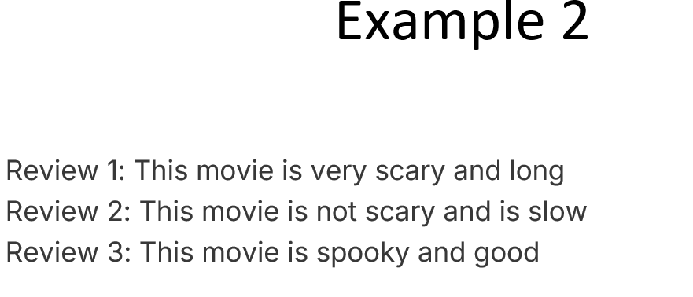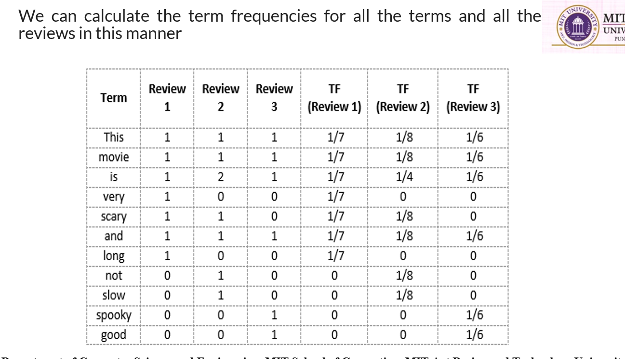
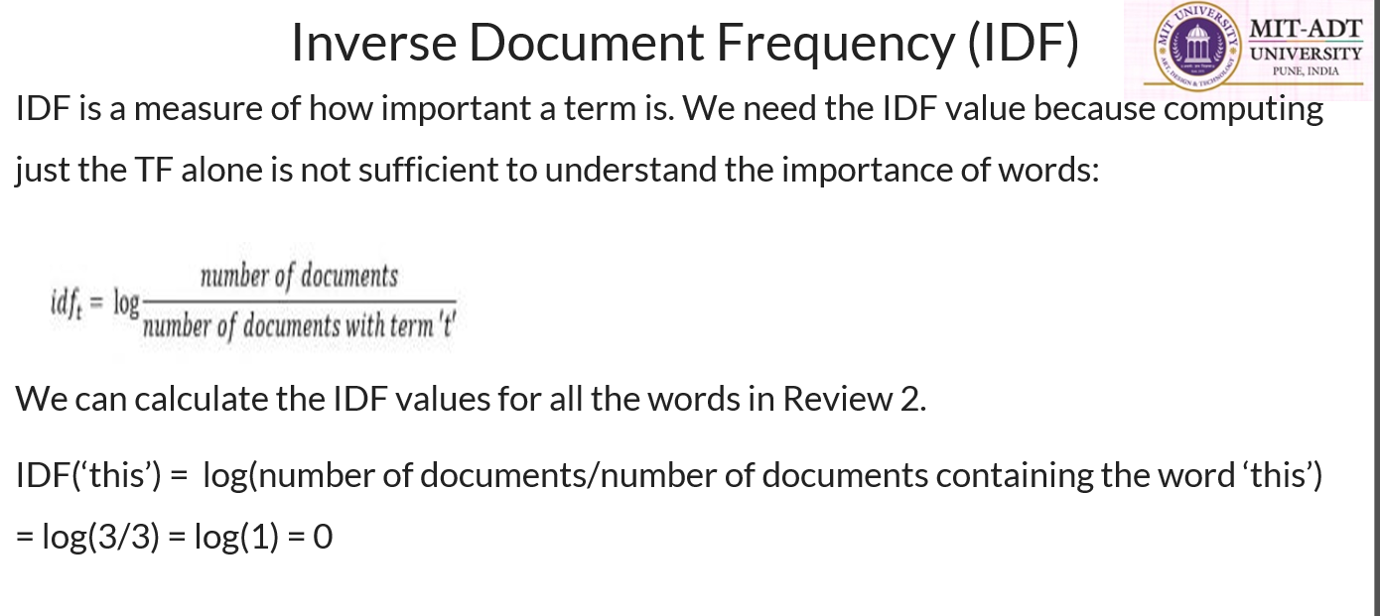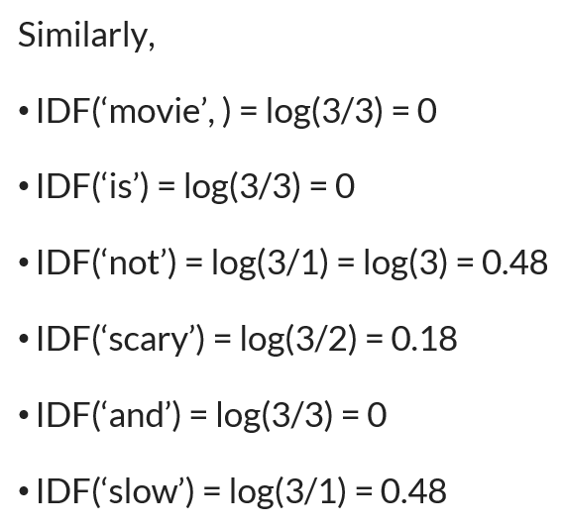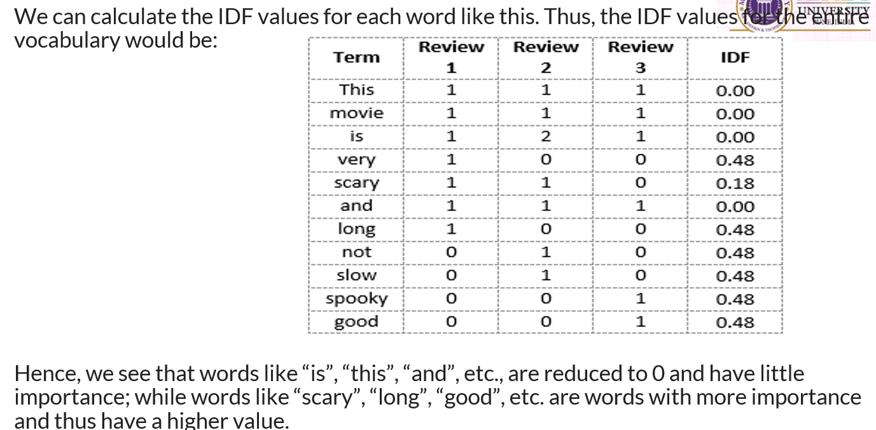
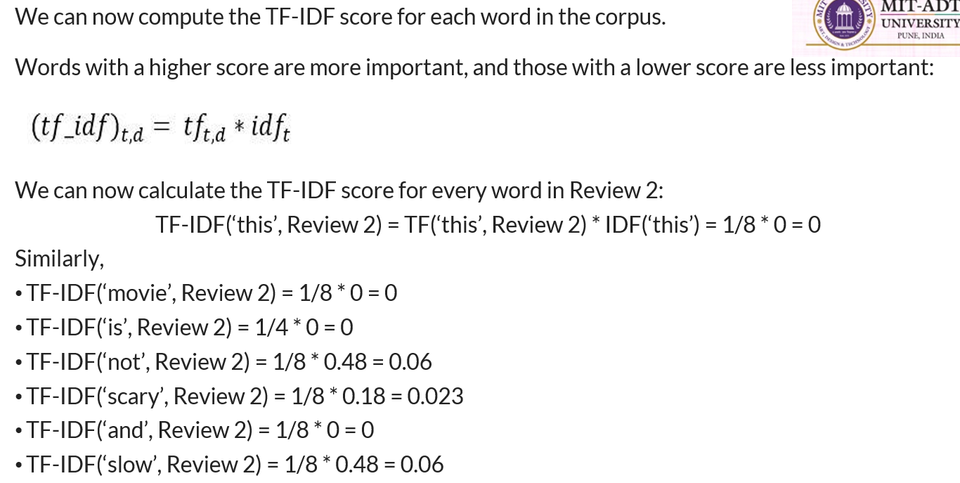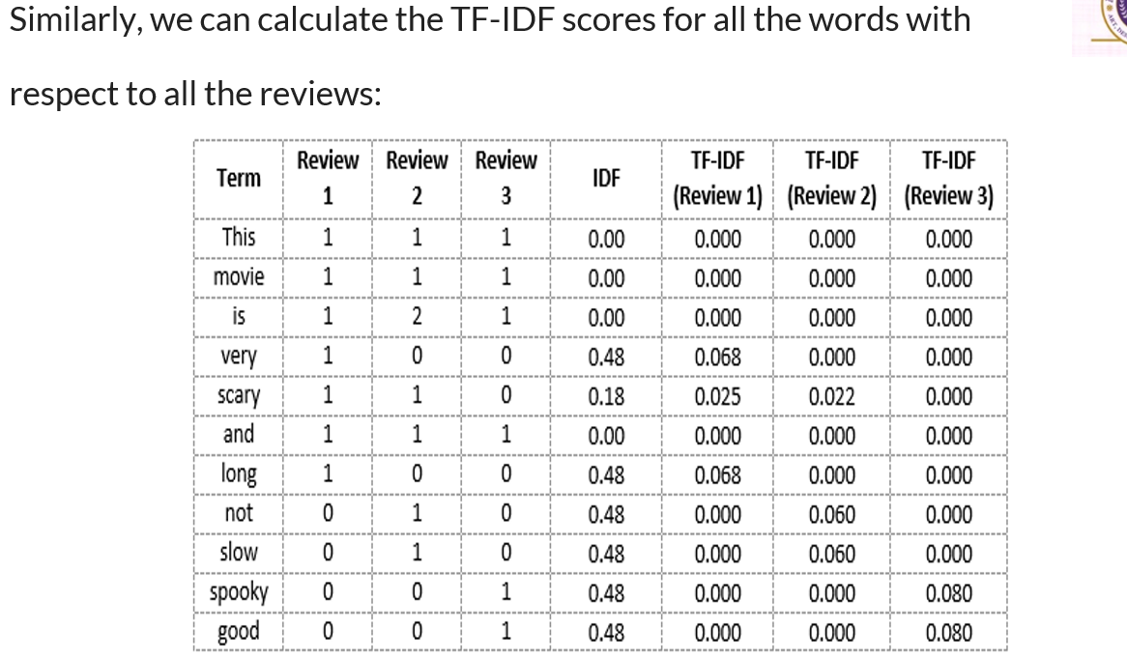
57. INFORMATION EXTRACTION (IE)
Information Extraction (IE) is the process of identifying and extracting useful information from large amounts of unstructured text.
It extracts specific pieces of information such as:
- Names
- Dates
- Relationships
- Other important facts
The extracted information can then be converted into useful and organized data.
Importance of Information Extraction
Information Extraction is important because it helps in:
- Enhancing Data Usability
- Automating Data Processing
- Supporting Decision-Making
Key Components of Information Extraction
The PPT lists three important components:
1. Named Entity Recognition (NER)
Identifies entities such as:
- Person
- Location
- Organization
2. Relationship Extraction
Identifies relationships between entities.
3. Event Extraction
Identifies important events from text.

58. RELATIONSHIP EXTRACTION
Relationship Extraction identifies the relationship between entities present in a text.
Example:
Sachin Tendulkar played for India.
Entities:
- Sachin Tendulkar → Person
- India → Country
Relationship:
played for
Thus, Relationship Extraction identifies:
Entity 1 → Relationship → Entity 2

59. UNSUPERVISED RELATIONSHIP EXTRACTION
Unsupervised Relationship Extraction identifies relationships without requiring labelled training data.
An important approach is:
Open Information Extraction (Open IE)
Open IE aims to identify relationships in text without:
- Labelled training data
- Predefined lists of relationships
In Open IE, relationships are generally represented as strings of words, often starting with a verb.
The objective is to extract relationships directly from the text without depending on prior knowledge or annotated examples.
Example of Open IE
Sentence:
Ravi works for Microsoft.
The extracted information can be represented as:
Ravi → works for → Microsoft
Here:
- Ravi = Entity 1
- works for = Relationship
- Microsoft = Entity 2

